##### GREEN HELP

**A PROJECT REPORT**

###### ***Submitted by***

|  |  |
| --- | --- |
| **DEVESH JAIN** | **20BCE10613** |
| **ANIKET DHOKANE** | **20BCE10736** |
| **HARSHIT GUPTA** | **20BCE10617** |
| **ANUP PAL** | **20BCE10641** |
| **MIRYALA KAUTILYA** | **20BCE10503** |

*In partial-fulfillment for the award of the degree*

*of*

##### BACHELOR OF TECHNOLOGY

*in*

**COMPUTER SCIENCE AND ENGINEERING**



**SCHOOL OF COMPUTING SCIENCE AND ENGINEERING**

**VIT BHOPAL UNIVERSITY**

**KOTHRI KALAN, SEHORE**

**MADHYA PRADESH - 466114**

**VIT BHOPAL UNIVERSITY, KOTHRI KALAN, SEHORE**

**MADHYA PRADESH – 466114**

**Date:12/12/2021**

**BONAFIDE CERTIFICATE**

Certified that this project report titled **“GREEN HELP”** is the bonafide work of “**DEVESH JAIN (20BCE10613), ANIKET DHOKANE (20BCE10736), HARSHIT GUPTA (20BCE10617)**, **ANUP PAL (20BCE10641) AND MIRYALA KAUTILYA (20BCE10503)”** who carried out the project work under my supervision. Certified further that to the best of my knowledge the work reported here does not form part of any other project / research work on the basis of which a degree or award was conferred on an earlier occasion on this or any other candidate.

**PROGRAM CHAIR PROJECT GUIDE**

Dr. Sandip Mal Dr. M Ashwin

School of Computer Science and Engineering School of Computer Science and Engineering

VIT BHOPAL UNIVERSITY VIT BHOPAL UNIVERSITY

**TABLE OF CONTENTS**

|  |  |  |
| --- | --- | --- |
| **CHAPTER NO.** | **TITLE** | **PAGE NO.** |
|  | **Abstract** | 5 |
| 1 | **INTRODUCTION** Introduction 1.2 Motivation for the work  1.3 Introduction to the project  including techniques  1.4 Existing work and limitation | 6  7  8 |
| 2 | **Technology used** | 9 |
| 3 | **SYSTEM DESIGN AND IMPLEMENTATION**  3.1 Module split up  3.2 Architecture diagram  3.3 flow diagram | 10  11 |
| 4 | **FUTURE ENHANCEMENT AND CONCLUSION**  4.1 Future Enhancements  4.2 Conclusion  4.3 References | 12  13 |

**ACKNOWLEDGEMENT**

First and foremost, I would like to thank the Lord Almighty for His presence and immense blessings throughout the project work.

I wish to express my heartfelt gratitude to **Dr. Poonkuntran sir**, Head of the Department, School of Computer Science for much of his valuable support and encouragement in carrying out this work.

I would like to thank my internal guide **Dr. Murgan Ashwin sir**, for continually guiding and actively participating in the project, giving valuable suggestions to complete the project work.

I would like to thank all the technical and teaching staff of the School of Computer Science, who extended directly or indirectly all support.

Last, but not the least, I am deeply indebted to my parents who have been the greatest support while I worked day and night for the project to make it a success.

**ABSTRACT**

GREEN HELP is a web development project that aims to spread awareness and solve issues related to environment. With the help of this website and some helping people, we aim to provide best solution to the people who connect with us for their environmental problems in their locality through our website. This project completely works on providing practical solutions and also make them aware about importance of green planet, keep them updated with current news. Which will help green and people will think green.

1. **INTRODUCTION**

**1.1. Introduction**

Pollution kills more than 1 million seabirds and 100 million mammals every year.

The number of people affected by pollution has been slowly on the rise. If it continues at this rate, it’ll exceed 840 million by 2030.

The COVID-19 pandemic also threatens to reverse decades of progress in the fight for mental and physical health.

In this situation helping each other is only a way to improve the current situation, we need to stand strong against MNCs, and governments taking actions against environment.

So, that’s by we came up with an idea of making a website that give solution to people, which is not run by any NGOs, this website work only on providing solutions, updates, and receiving issues (no money’s donation) this our small initiative can help people getting updated and promote environmental conservation.

**1.2. Motivation for the work**

*“Never doubt that a small group of thoughtful, committed citizens can change the world; indeed, it's the only thing that ever has”*- Margaret Mead

We get the motivation for this project from many changes taking place on Earth. There are many people like Leonardo DiCaprio, Greta Thunberg, etc. who are selflessly working against climate change action. So, we as developers also thought of doing something in the field of software that can promote Environmental Conservation.

1.3. **Introduction to the project including techniques.**

**GREEN HELP**

An integrated web application project with aim taking the charge in gathering like-minded individuals together for the common purpose of protecting the environment. Our goal is to ensure the ability of the earth to nurture life in all its diversity. We believe optimism is a form of courage. We believe that a billion acts of courage can spark a brighter tomorrow. To that end we model courage, we champion courage, we share stories of courageous acts by our supporters and allies, we invite people out of their comfort zones to take courageous action with us, individually in their daily lives, and in community with others who share our commitment to a better world.

**How does GREEN HELP work?**

GREENHELP does not require any involvement of real time gathering, this website completely works with the help of updating people across the globe and receive their feedbacks from their localities.

The aim of our website will cover every country of the world. The individual belong to particular area can share problems related to environment in his/her local area with the help of website efficiently. Our website will take responses from the user and store it in database, then we will provide with them expert solutions to the problems.

Using News API we provide a platform for presenting ‘Climate’ related news.

**1.4 Existing work with Limitations**

There is no such site which showcases Environmental conservation ideas, with collecting user response through chat bot application, Weather News.

The project needs a big Database for storing its user response data. Currently we are working on displaying the problems of people onto a new page of our website.

**2. Technology used**

* **Languages and technology used**
* HTML, CSS, JAVASCRIPT - for frontend website development.
* Bootstrap, SAAS CSS framework for frontend.
* Collect.chat, Formspree APIs for user data collection
* Pushed with GitHub.
* Hosted through Netlify.
* **Hardware and Software used.**
* Operating system - Windows
* Visual Studio code editor for HTML, CSS and JAVASCRIPT
* Online RSS script Editor

**3.SYSTEM DESIGN AND IMPLEMENTATION**

**3.1 Module split up**

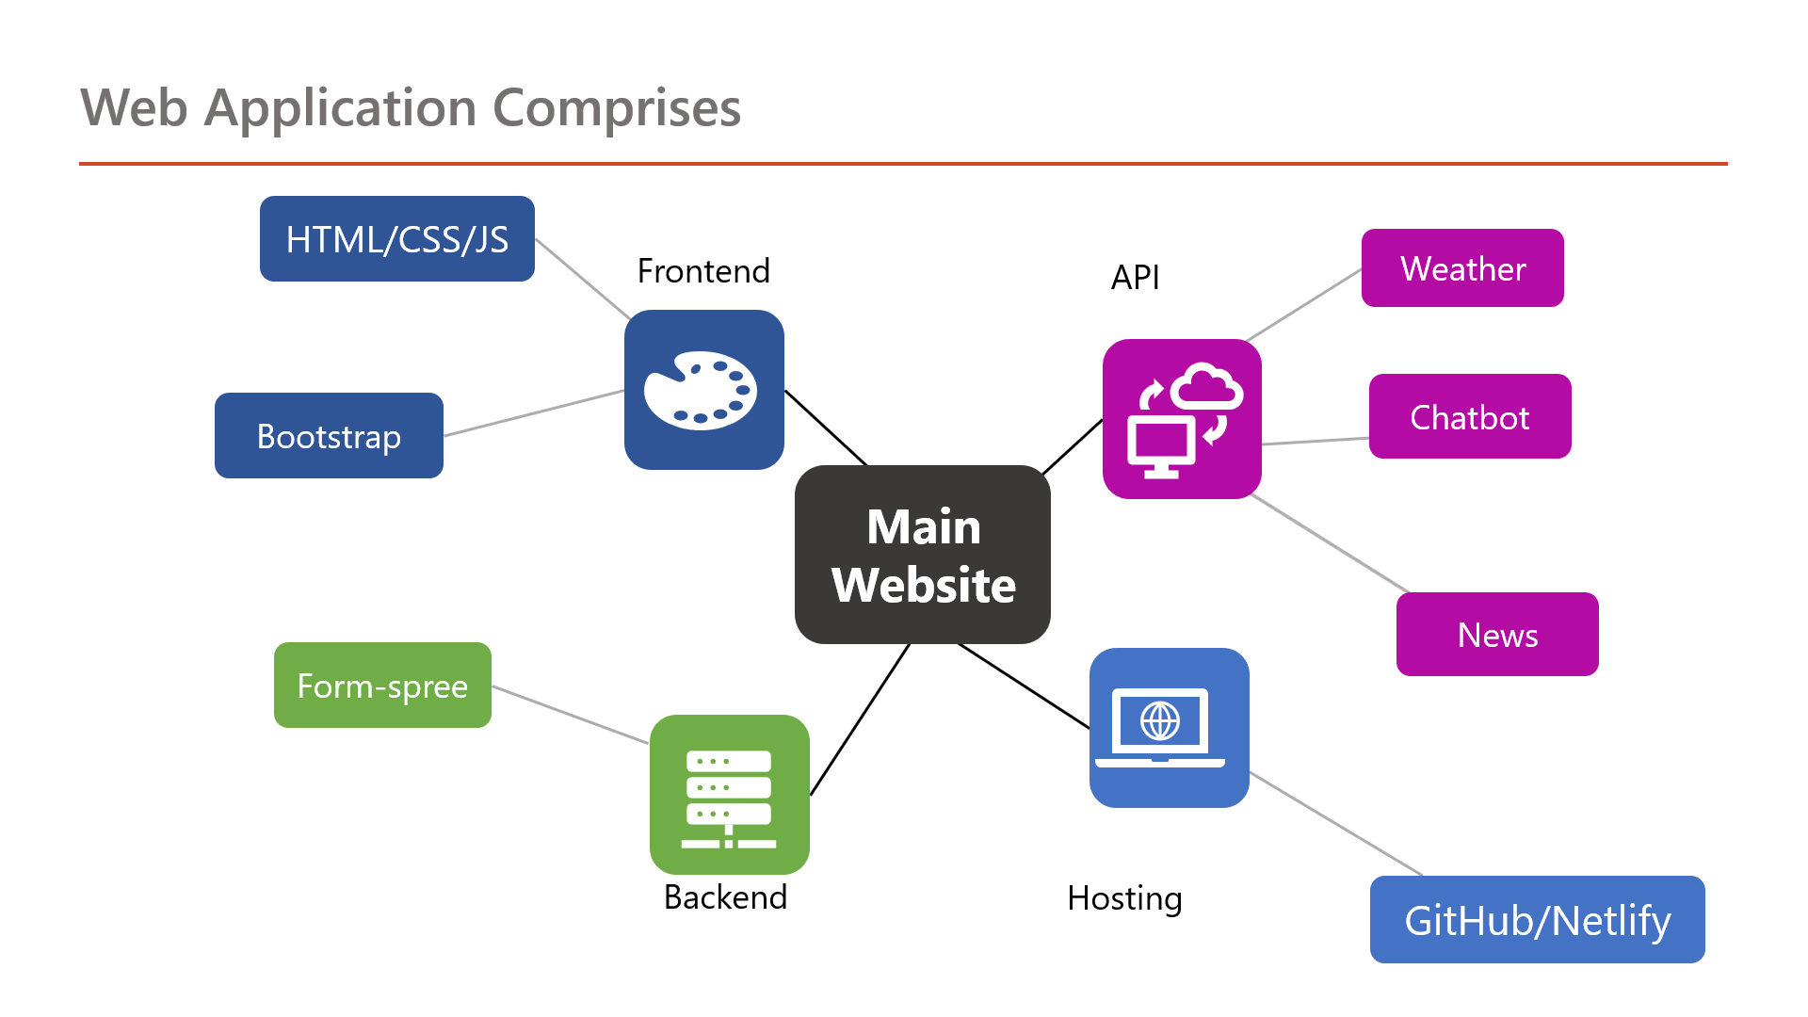

**3.2. Architecture diagram:**

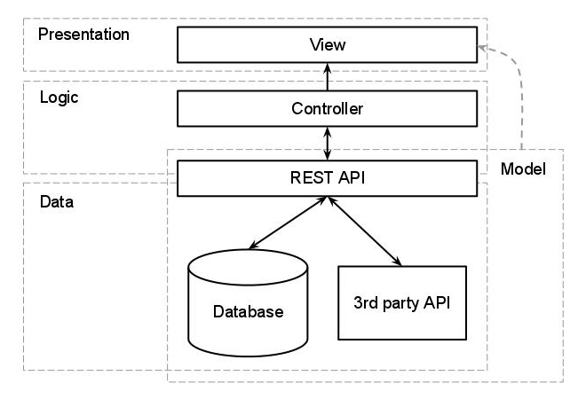

**3.3 Flow diagram**

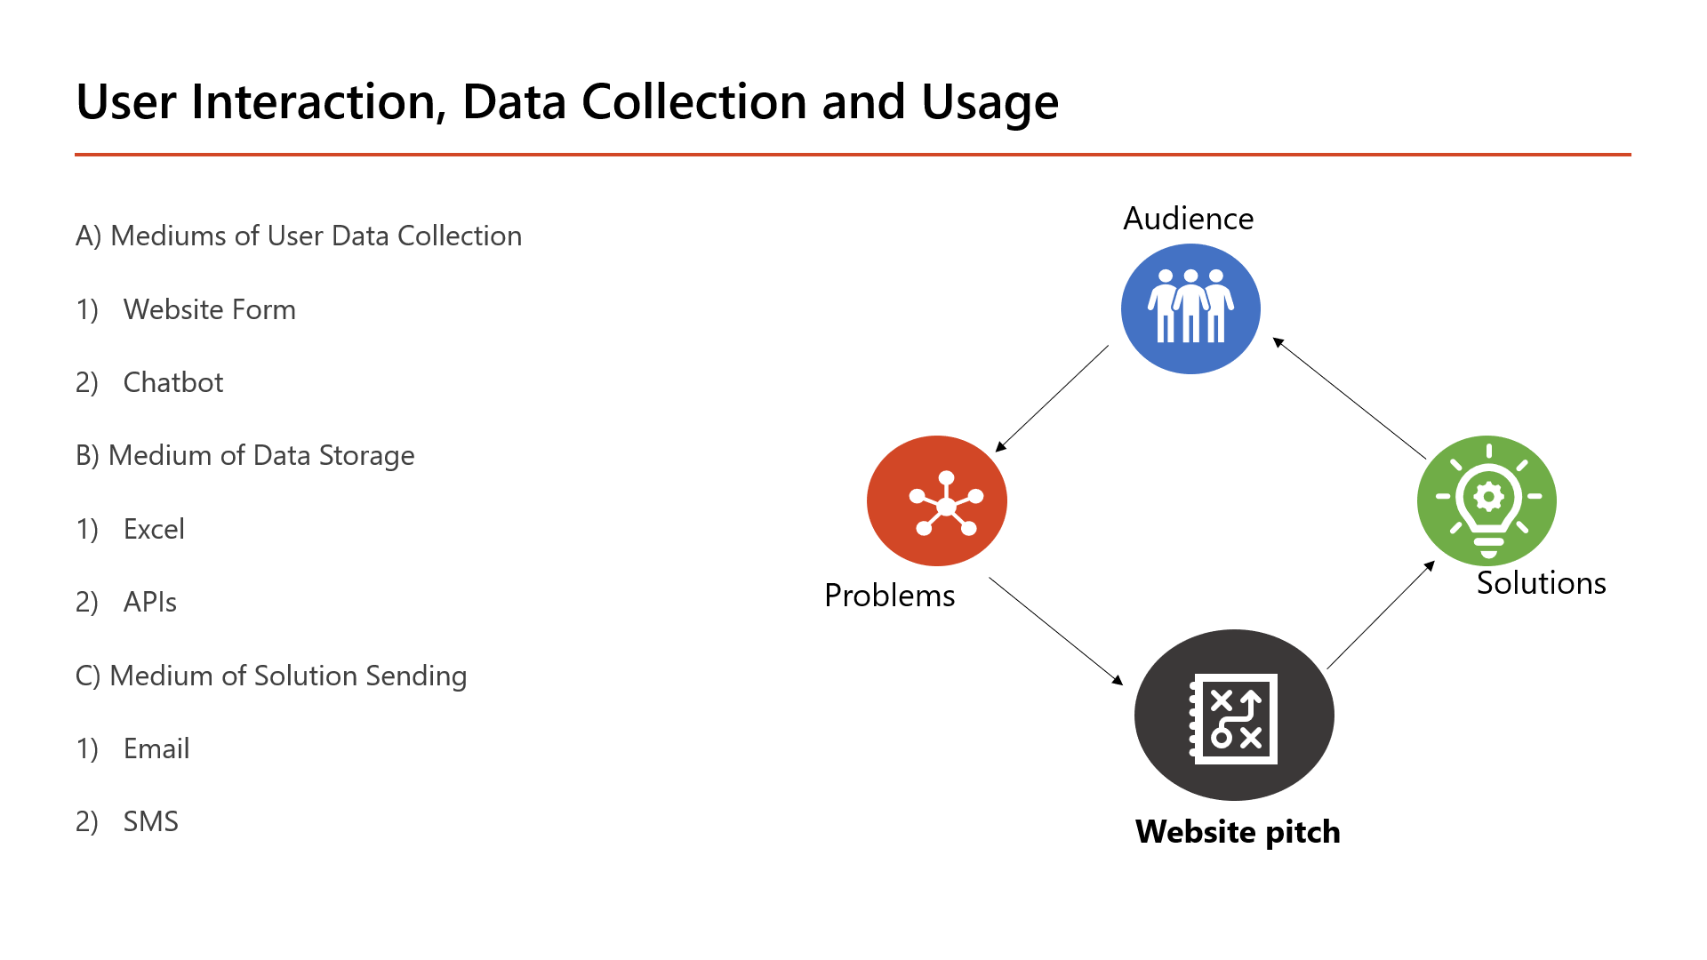

**4.1 Future Enhancements**

* In future, we will implement the voice to text technology to collect user data and text to voice to read out website articles.
* Will Shift its Code Base to **MERN** stack
* We will try to make our website’s UI more user friendly so that users have to make least effort on this website.
* We will add more features as possible that will help people to provide best solution possible for environmental issues in their locality.
* Bring new Ideas to make people **Think Green.**

**4.2 Conclusion**

During our project we understood the importance of Environment. We have been able to learn many new skills in web development and deployment, along with the usage of APIs, frameworks, data fetching, etc. This project gave us an experience of tackling with real time problems, and drawing solutions to it.

**4.3 References**

Sources of Information

1. <https://www.greenpeace.org/india/en/>
2. <https://www.wikipedia.org/>

Development

1. <https://freefrontend.com/>
2. <https://fontawesome.com/>

List of APIs used

1. chatbot - collect.chat (<https://dashboard.collect.chat/>)
2. html form - formspree (<https://formspree.io/>)
3. weather forecast - openweathermap (<https://openweathermap.org/api>)
4. climate news - insideclimatenews (<https://insideclimatenews.org/>)

RSS.app (<https://rss.app/> )